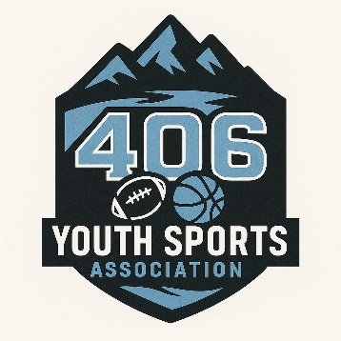
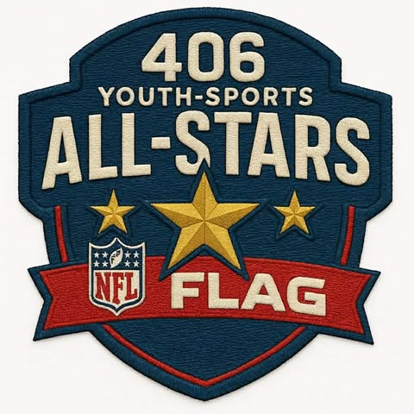
Great Falls
ALL-STARS
Coach Vote Only
How it works: The head coaches from each team in the eligible division vote for players from the entire pool (typically excluding their own roster).
The case for it: Coaches have watched these kids play all season. They have seen them in competitive situations, under pressure, across dozens of games. They know who can handle intense game play moments, who falls apart when they are behind in the count, and who has the temperament to handle tournament pressure. Season-long observation is a better predictor of tournament performance than any single tryout or popularity contest.
Selection will be based on the following factors:

- overall skill level
- stats
- attendance/dedication
- team player
- game wins
- clutch moments
- leadership skills
- attitude and sportsmanship
- coachability
- availability
Team Division:
PLAYGROUND DRAFT STYLE
ALL-STAR COACHES:

George Fontanez Team GREEN
Mitchell Morris Team BLACK

**1 ALL-STAR game per Division**
**2 ALL-STAR Teams (7 players) per Division**
**1 CHAMPION per Division**

